**PUBLIC TRANSPORT OPTIMISATION**

**PHASE 5 PROJECT**

**INTRODUCTION:**

In this, project we'll delve deeper into enhancing the efficiency and accessibility of public transportation systems. By addressing key challenges and implementing innovative solutions, we aim to create a more sustainable, convenient, and eco-friendly urban mobility experience for all. This introduction sets the stage for the exciting journey ahead as we explore various strategies and technologies to optimize public transportation.

**OBJECTIVE:**

In the context of public transportation optimization, the integration of Internet of Things (IoT) sensors in vehicles presents a transformative solution. IoT sensors, strategically embedded in buses, trains, and other transit vehicles, enable real-time monitoring of ridership, vehicle locations, and predictive arrival times. This abstract explores the implementation of IoT sensors as a means to enhance public transit services. The data collected from these sensors can be made available to the public via digital platforms, providing passengers with valuable information to plan their journeys more effectively. This technology-driven approach not only improves the efficiency of public transportation but also contributes to a more sustainable and passenger-centric urban mobility ecosystem. The abstract emphasizes the importance of data transparency and accessibility in shaping the future of public transit services**.**

**APPLICATIONS:**

1.Improved Service Reliability

2. Reduced Congestion

3. Enhanced Passenger Experience:

4. Increased Ridership:

5. Cost Savings:

6. Environmental Sustainability:

7. Equity and Accessibility:

8. Data-Driven Decision-Making:

9. Emergency Response and Disaster Management:

10. Integration with Other Modes of Transport:

11. Economic Growth:

12. Tourism Promotion:

13. Reduction of Energy Consumption:

14. Reduced Infrastructure Strain:

15. Safety Improvements:

16. Long-Term Planning:

These applications demonstrate the wide-reaching benefits of implementing a public transportation optimization project, improving transportation systems for both the passengers and the communities they serve.

**BLOCK DIAGRAM:**

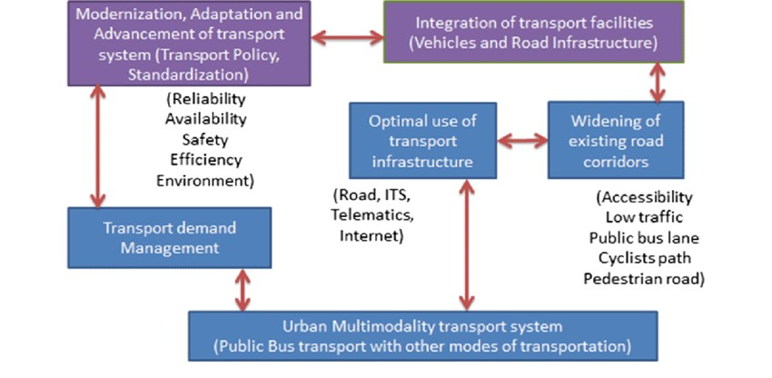

**SCREENSHOTS OF THE PROJECT IMPLEMENTATION:**

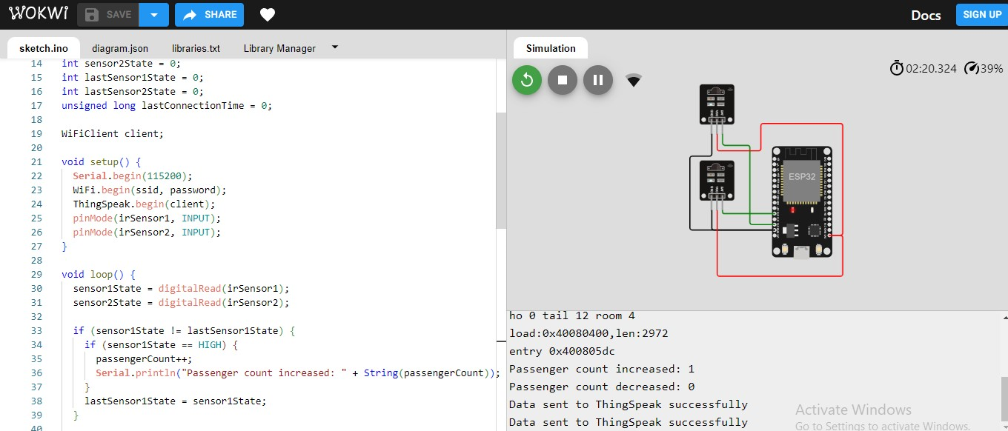

**OUTPUT:**

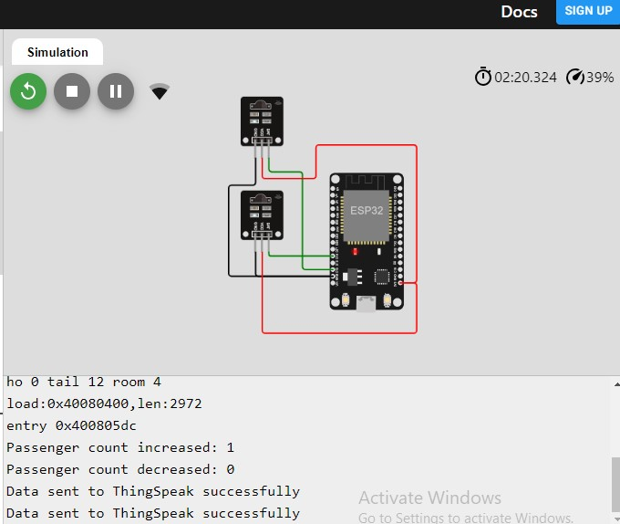

**THUS THE OUTPUT HAS SUCCESSSFULLY EXCECUTED.**

**CONCLUSION:**

The main objective of this work was the development of a tracking system to assist in alleviating the problem of unpredictability of bus arrival time. For this, a Web system and an App, capable of obtaining current bus positions, were developed. After the development of the Web system and App, the embedded

system was attached to a bus to obtain the vehicle position and to send that information to a server. Different technologies were used for the development of the Web system and the application. Some of these technologies were Django, Bootstrap, and Leaflet. They streamlined the development of the system and ensured good structuring of the project. With the good organization of the codes, it was possible to reuse a large part of the functions.